
AUGUST – DECEMBER 2025
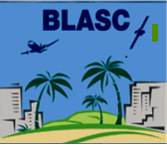
August GMM
November GMM
December GMM
Upcoming BLASC Events
BLASC Vision & Mission Statement
BLASC Board of Directors
BLASC Executive Advisor

- AUGUST GMM
SCHOLARSHIP PRESENTATION - IN WORK
- NOVEMBER GMM – IN 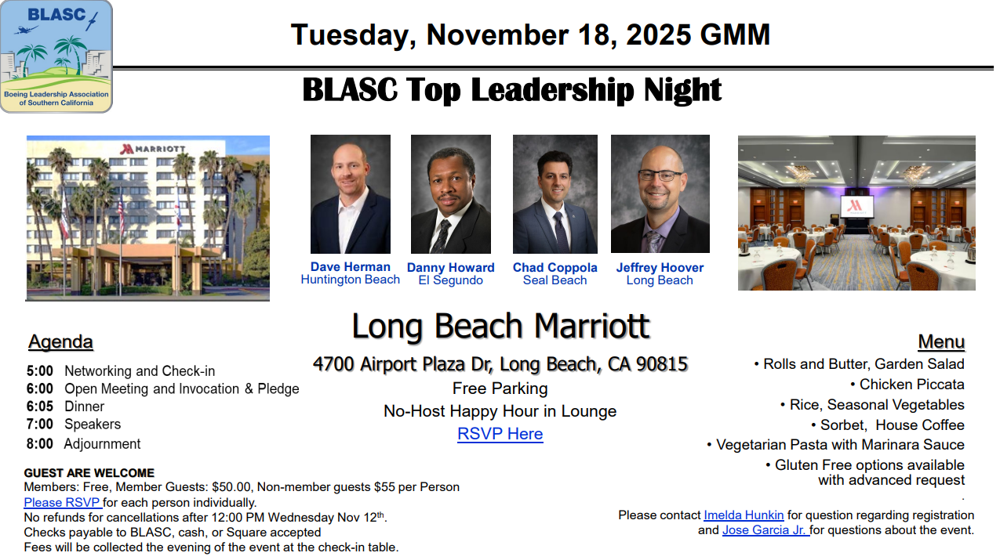

- DECEMBER GMM – IN WORK
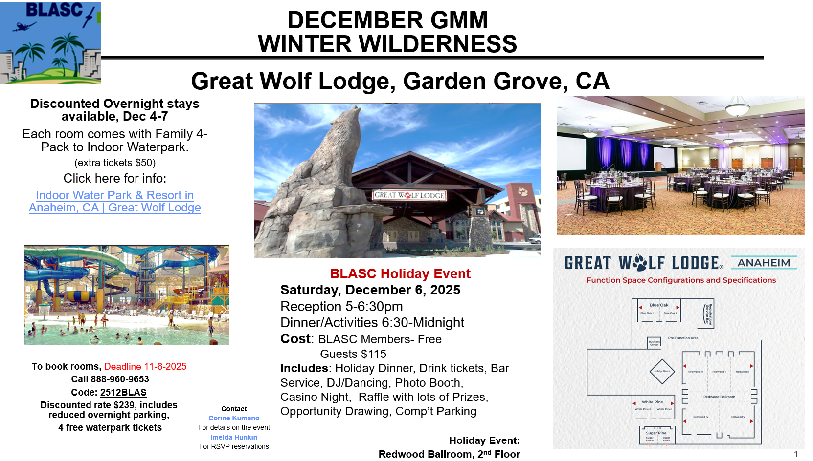
DECEMBER 6, 2025, 5:00PM -12:00AM
Step into a magical Winter Wilderness this Christmas, where the sparkling beauty of snow-covered forests sets the stage for an unforgettable celebration. Immerse yourself in an enchanting atmosphere filled with twinkling lights, frosted pinecones, and rustic woodland charm. From cozy fireside conversations to festive treats inspired by nature’s bounty, our party promises warmth, wonder, and a true spirit of the season. Embrace the wild beauty of winter and join us for a night of laughter, camaraderie, and holiday cheer!
Cost: BLASC Members- Free
Guests $115
Includes: Holiday Dinner, Drink tickets, Bar Service, DJ/Dancing, Photo Booth, Casino Night, Raffle with lots of Prizes, Opportunity Drawing, Comp’t Parking
Holiday Event: Redwood Ballroom, 2nd Floor
- Discounted Overnight stays available, Dec 4-7; Each room comes with Family 4-Pack to Indoor Waterpark. (extra tickets $50)
Click Here for more details.

- UPCOMING EVENTS

- Boeing Family Day in Long Beach is September 20th
- Family Day will be held at Long Beach. 9am to 2pm.

- JULY SPECIAL EVENT
JOINT LEADERSHIP EVENT AT PROUD BIRD – IN WORK
JOIN US FOR A DELIGHTFULL NETWORKING HAPPY HOUR, WHERE YOU CAN UNWIND AND CONNECT WITH AMAZING PEOPLE IN A LIVELY AND CHEERFUL ATMOSPHERE!
ENJOY REFRESHING DRINKS, TASTY SNACKS, AND ENGAGING CONVERSATIONS THAT COULD SPARK NEW OPPORTUNITIES AND FRIENDSHIPS.
- OCTOBER SPECIAL EVENT
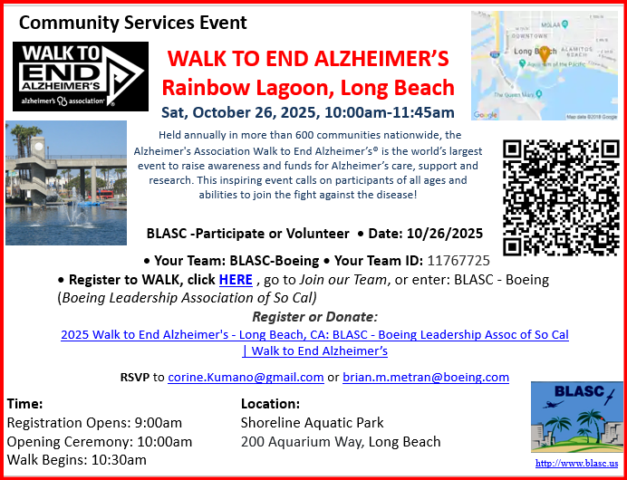

- NOVEMBER SPECIAL EVENT: GIRLS SCOUT EVENT ON NOV. 2 @ OC Fair Grounds

Check our Web Site regularly for new and exciting events throughout the year at https://blasc.us/

BLASC VISION AND MISSION
Vision: Building organizational partnerships that accelerate leadership development in our workplace and our communities
Mission: Inspire, develop and connect leaders by providing growth opportunities for our members and contributing to our community through:
- Hosting motivational and entertaining social events to foster unity
- Providing accelerated training and development opportunities to drive business and professional success
- Partnering to provide and enhance talent development for our Boeing sponsors
- Investing in charitable causes and exceptional students

- BLASC Board of Directors
BLASC Board of Directors constitutes the governing body of BLASC and is responsible to the members.
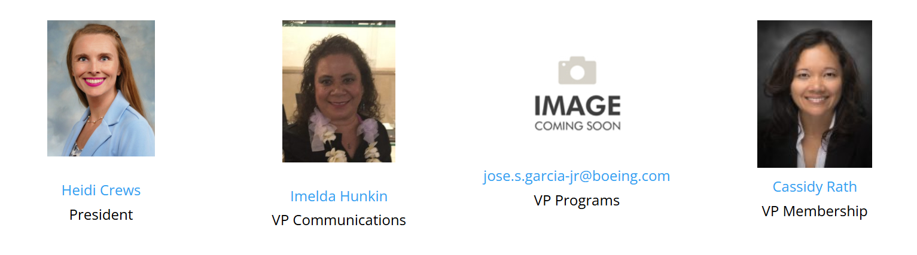
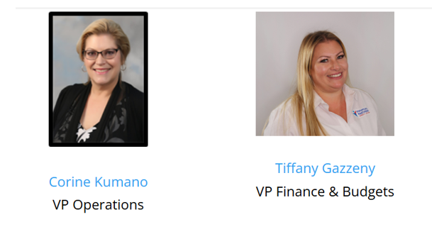
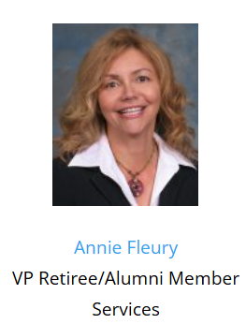

- BLASC Executive Advisor
BLASC Executive Advisors counsel and mentor BLASC Board members. Thank you for your support and encouragement.

