
JANUARY – APRIL 2025
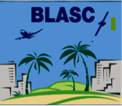
President’s Message
February GMM
April GMM

- WELCOMING FROM THE PRESIDENT
As president of the Boeing Leadership Association of Southern California for 2025, I am honored to officially welcome you to another great year with BLASC. I am excited to continue to offer many meaningful events this year. As a board, we a committed to continuing to serve you to the best of our abilities, so please share any ideas you have about how we can improve the organization together.
Several new members have already joined in 2025, and we hope to continue to grow. I encourage each of you to share BLASC with your coworkers and encourage them to become members. If you would like to become more involved with welcoming new members or have suggestions about how we can bring in more new members, please reach out to Cassidy Rath, our VP of Membership.
This year, our board consists of both new and returning members. I am happy to see the new ideas and collaboration that have led to some great events so far in 2025, and I am looking forward to what the rest of the year will bring. Hopefully you have had a chance to join us for at least one of our four general membership meetings so far this year. We have had a variety of outstanding speakers. There are still two more meetings in 2025, as well as other events. I encourage you to attend as many of our offerings as you are able and hope to see you at our October GMM!
- FEBRUARY GMM
Networking for Success and Wine Tasting
The Boeing Leadership Association of Southern California (BLASC) welcomed members and guests to the February General Membership Meeting with an evening dedicated to connection, community, and wine tasting. Held at the Old Ranch Country Club in Seal Beach, the event created the perfect atmosphere to kick off the 2025 programming year.
The night began with a warm welcome and a reminder of the importance of coming together as a leadership community. After enjoying a delicious dinner and sampling wines, attendees shifted into the main program: Networking for Success.
Rather than sticking to the usual small talk, members were encouraged to share more meaningful parts of their lives—personal passions, proud accomplishments, family stories, and even dreams for the future. With structured rounds of conversation and plenty of opportunities to meet new faces, the room buzzed with energy as people discovered common ground and fresh perspectives.
To keep things fun, raffle prizes were woven into the networking sessions, adding excitement and a few lucky winners to the evening.
The event closed with reflections on the power of genuine connection and encouragement to carry these new relationships forward. By the end of the night, the February GMM had done more than bring people together—it reminded everyone of the strength and value of the BLASC community.
- APRIL GMM

The “Indiana Jones” of Aviation Captivates BLASC
The Boeing Leadership Association of Southern California (BLASC) gathered at the Long Beach Marriott on April 23, 2025, for an evening that blended camaraderie, good food, and a once-in-a-lifetime storytelling experience. The featured speaker, Ralph Wetterhahn, is not just an aviation expert—he’s earned the nickname the “Indiana Jones of Aviation” for his fearless pursuit of lost aircraft, hidden wrecks, and untold stories from the past.
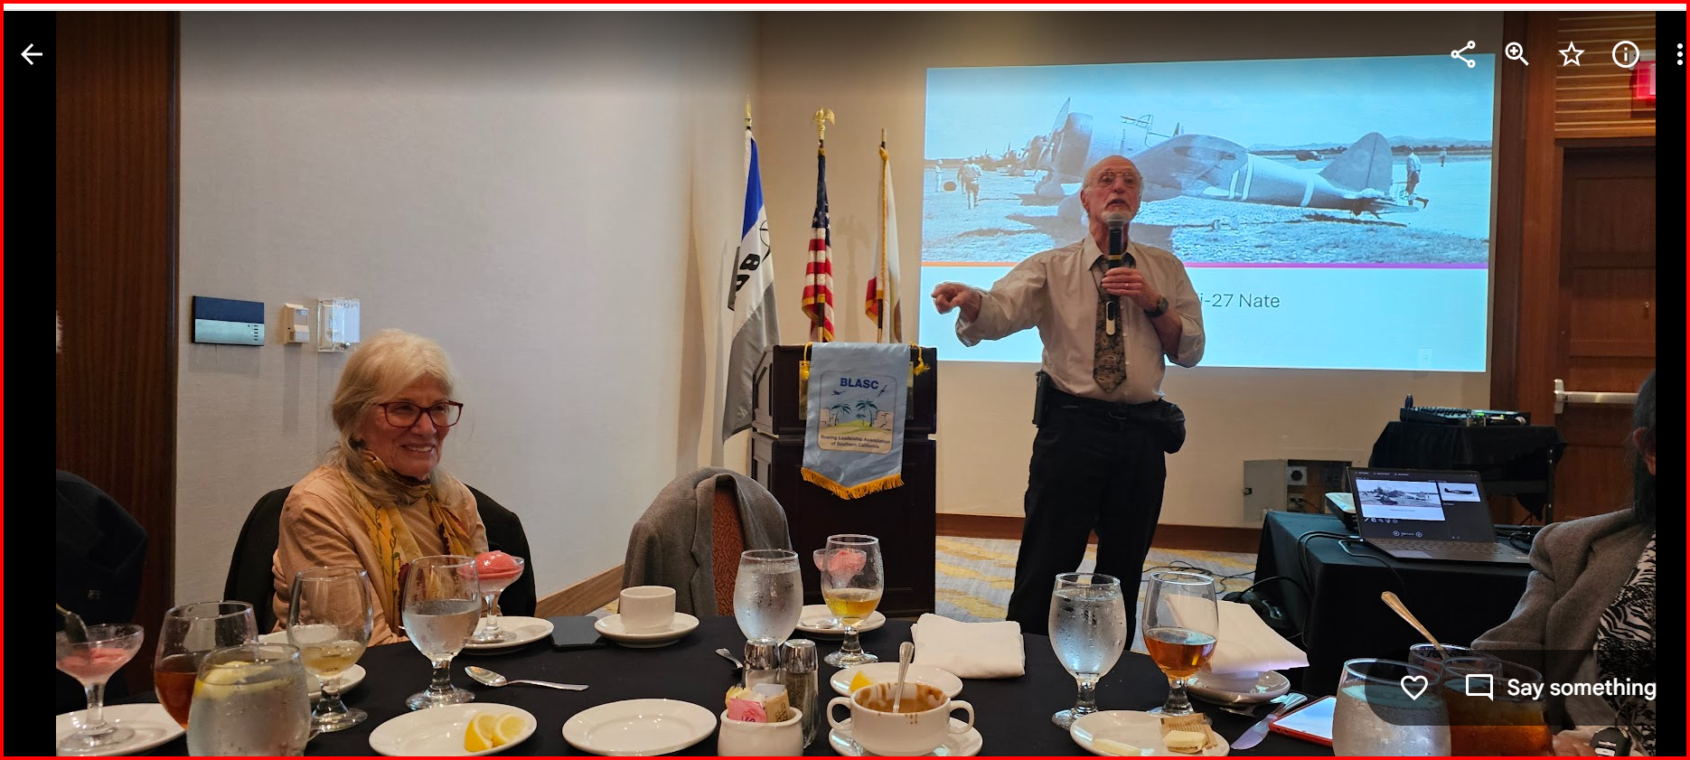
From the moment Ralph took the stage, the audience was hooked. His presence was commanding yet approachable, and his stories unfolded with the kind of energy that made listeners feel like they were right there beside him—in a jungle clearing, on a remote island, or high above the clouds in combat.
Ralph’s journey began as a fighter pilot, graduating from the U.S. Air Force Academy in 1963 before serving three combat tours during the Vietnam War. He flew 180 missions in the F-4 Phantom and A-7 Corsair, downed a MiG-21 in the now-famous “Bolo Mission,” and completed 144 carrier landings. Later, he logged over 1,000 hours in the F-15 Eagle. But as impressive as his military record is, it’s what came after that makes his story truly extraordinary.
In what many would call a second career; Ralph transformed into an aviation archaeologist. With boundless curiosity and respect for history, he has traveled to some of the most remote and challenging places on earth—Cambodia, Guadalcanal, the Russian Far East, the Philippines—tracking down aircraft wrecks and unraveling mysteries surrounding missing-in-action service members. These expeditions are not just technical recoveries; they’re deeply human stories that provide closure for families and honor the sacrifices of those who served.
His work has been featured in documentaries on NOVA, Discovery, and National Geographic, including The Last Flight of Bomber-31 and Missing in MiG Alley. He’s also the author of several acclaimed books, including The Last Battle, which won the prestigious Colby Award. Each story he shared blended adventure, history, and emotion in a way that left the audience both educated and deeply moved. 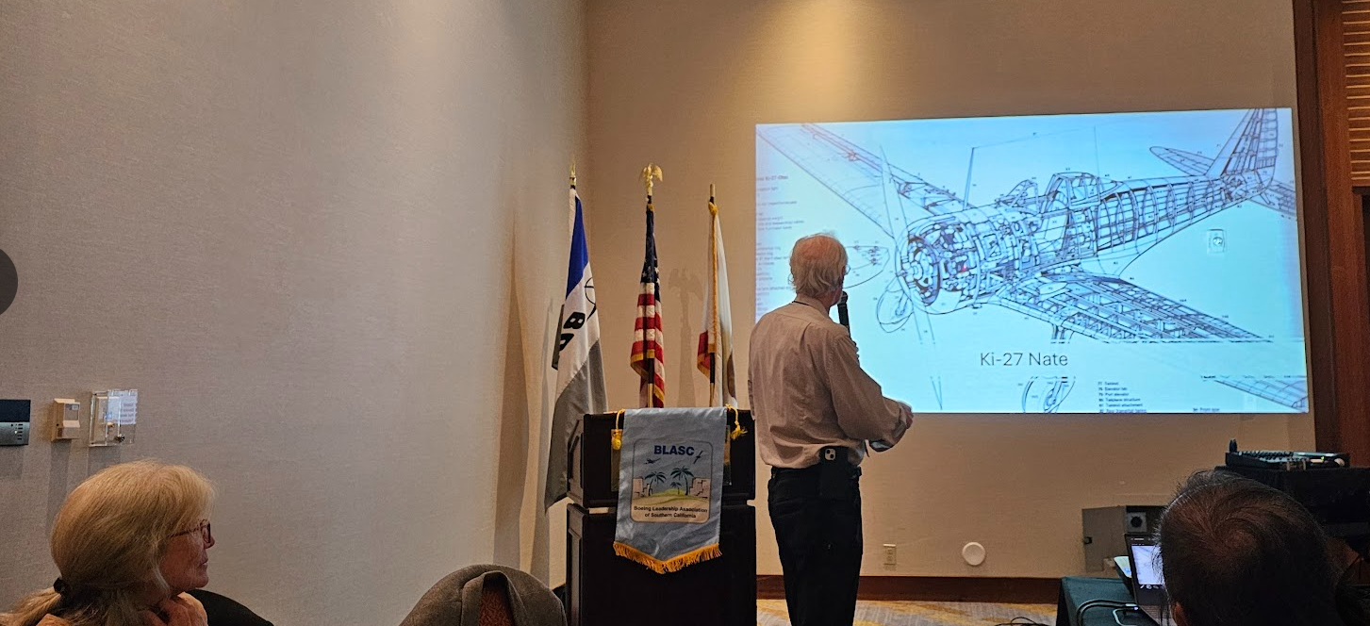
As he recounted his adventures—sometimes dangerous, sometimes painstaking, always fascinating—the room was silent except for bursts of laughter at his dry humor and the audible gasps when he revealed an unexpected twist or discovery. His passion for uncovering the truth was infectious, and his respect for the aviators who came before him gave every tale a powerful sense of purpose.
The evening wrapped up with a brief Q&A and a book signing, where members eagerly leaned in to learn more about Ralph, his most memorable discoveries, and what drives him to keep searching. It was clear that his talk struck a chord, reminding everyone present of the value of perseverance, curiosity, and honoring history. 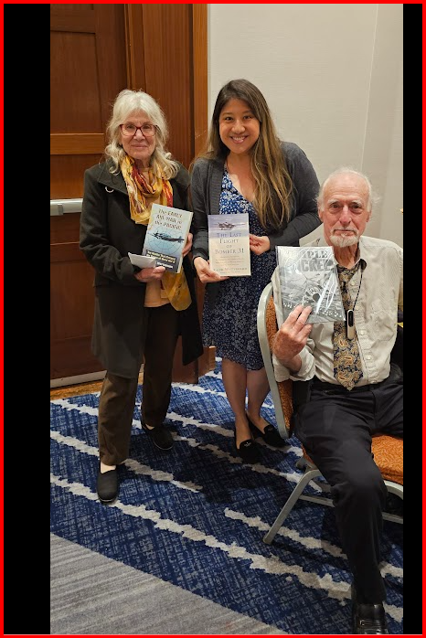
The April meeting was more than just another event on the calendar—it was a rare opportunity to step into the shoes of a modern-day adventurer and see aviation history through the eyes of someone who has lived it, fought for it, and dedicated his life to uncovering it. BLASC members left inspired, energized, and grateful to have been part of such a memorable evening.

